**Spring Framework**

**Date 03/03/2021**

**Google Doc link :** [**https://docs.google.com/document/d/1M58cHhSSeFF91g9CW0xageDYQRjH2JH5WpUV_aprsms/edit?usp=sharing**](https://docs.google.com/document/d/1M58cHhSSeFF91g9CW0xageDYQRjH2JH5WpUV_aprsms/edit?usp=sharing)

**(1) Write a program to demonstrate Tightly Coupled code.**

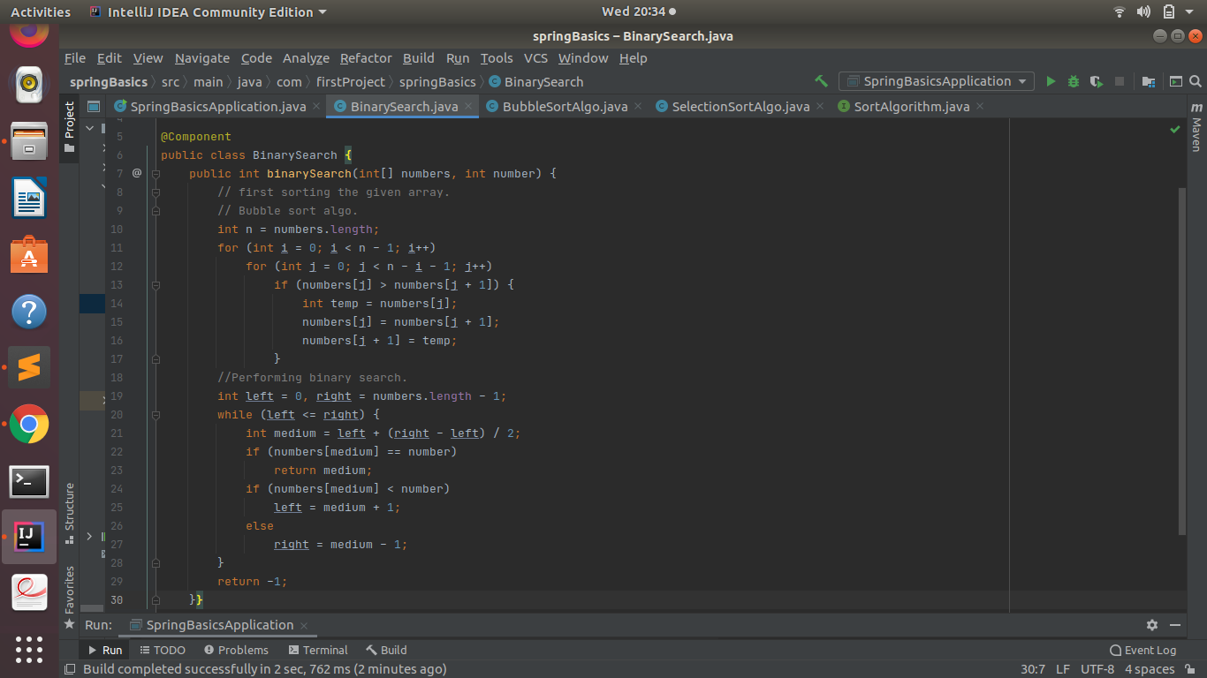

**(2) Write a program to demonstrate Loosely Coupled code.**

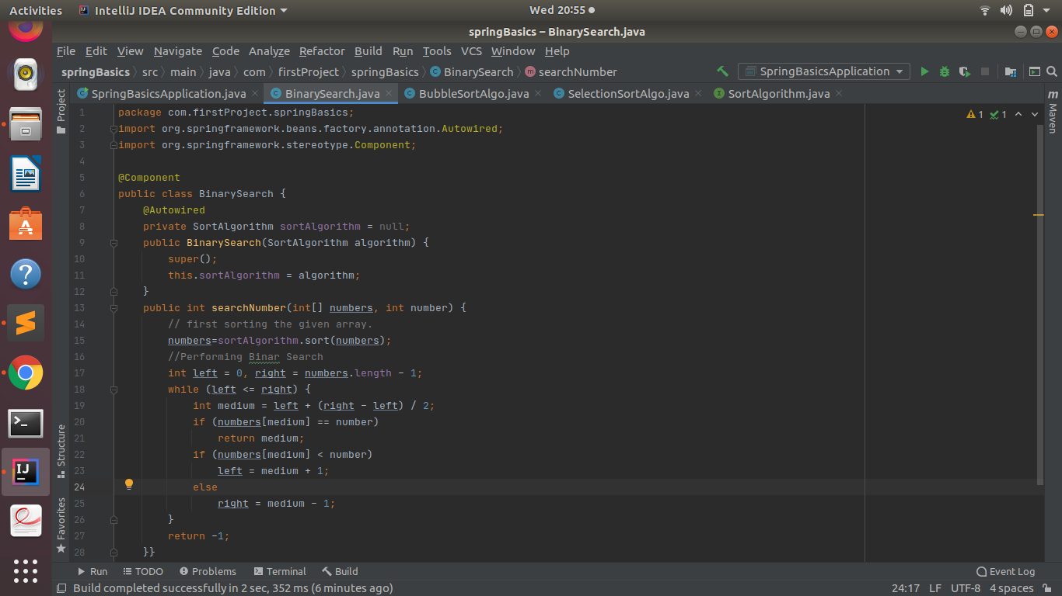

**(3) Use @Compenent and @Autowired annotations to in Loosely Coupled code for dependency management**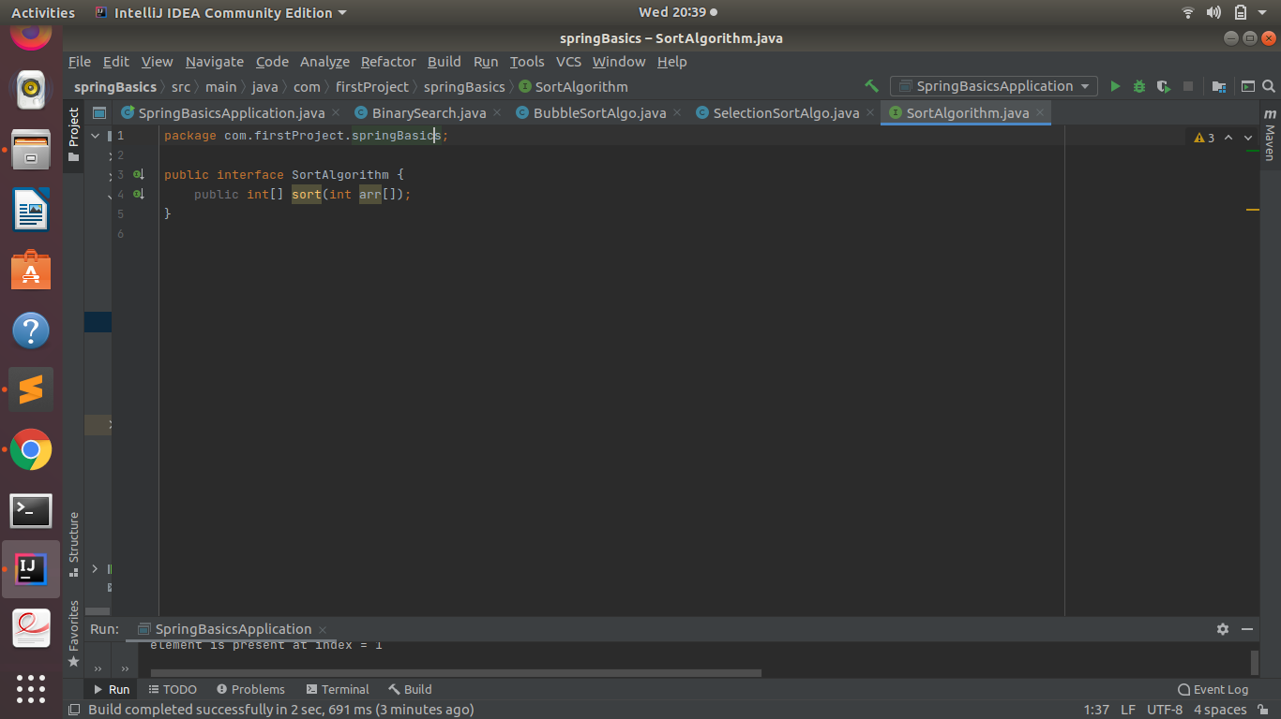

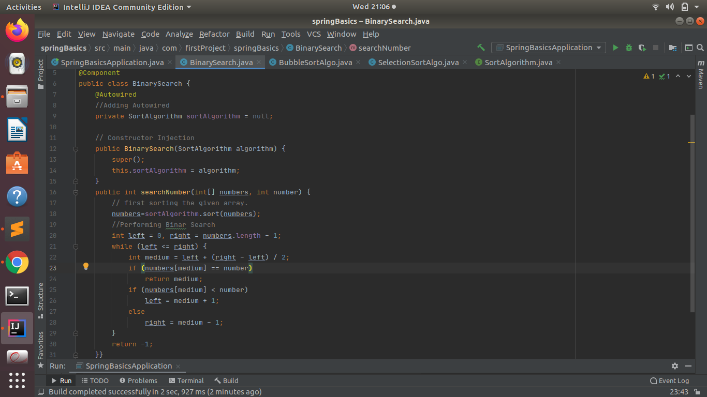

**(4) Get a Spring Bean from application context and display its properties.**

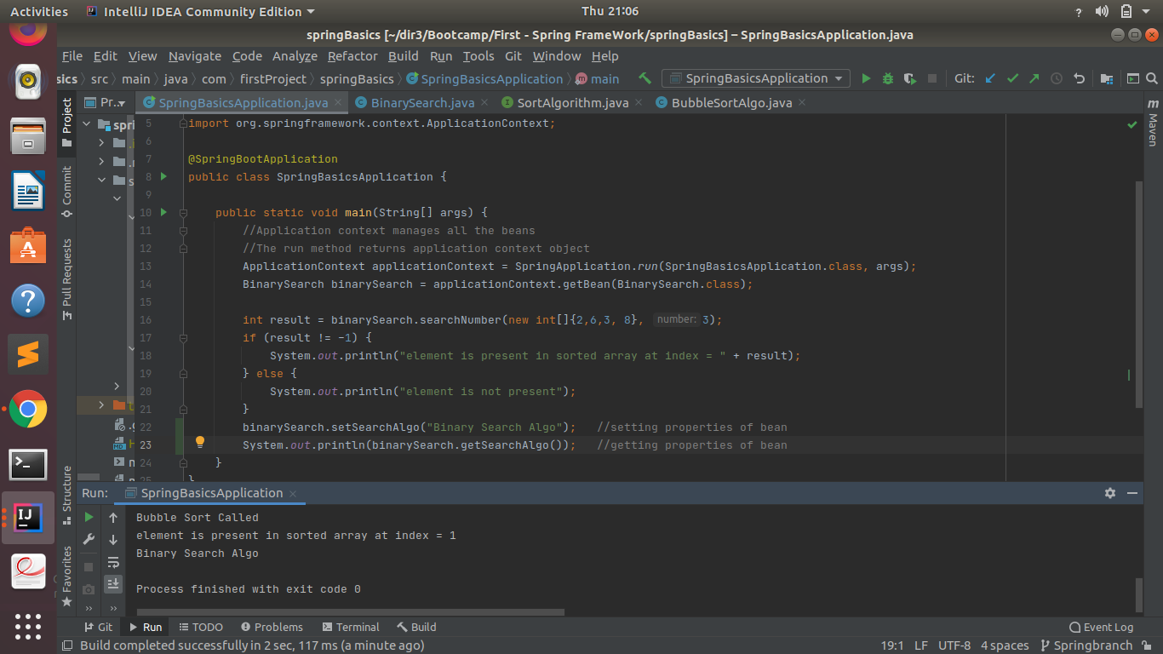

**(5) Demonstrate how you will resolve ambiguity while autowiring bean (Hint : @Primary)**

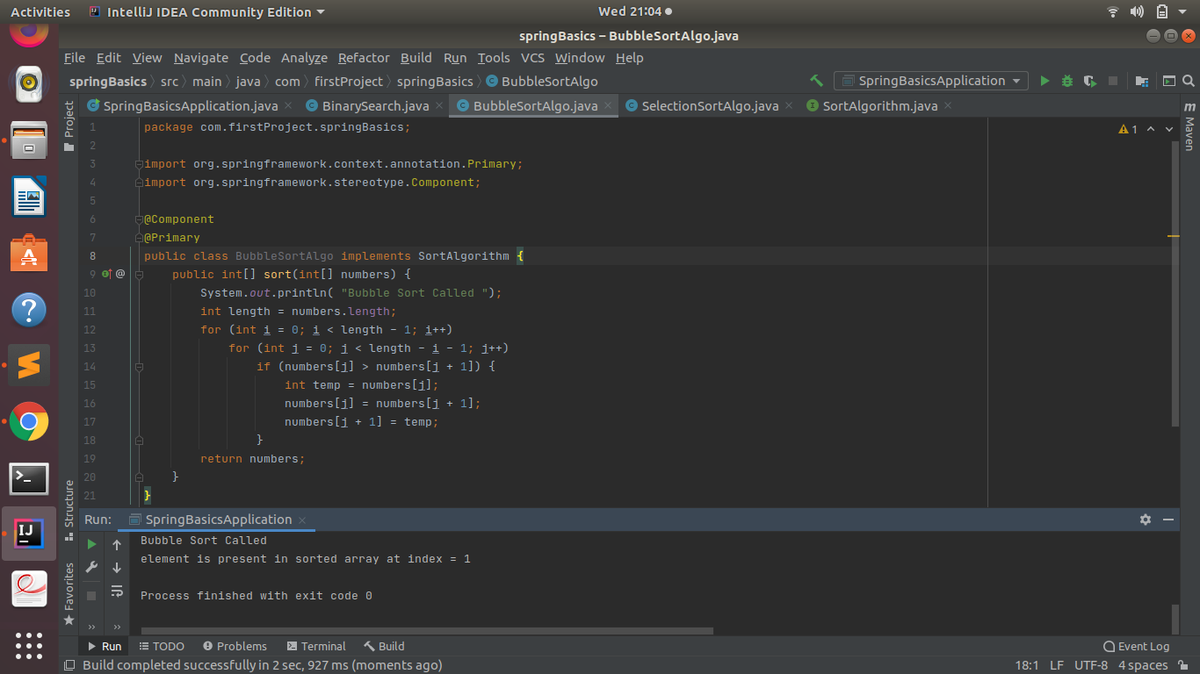

**(6) Perform Constructor Injection in a Spring Bean**

